

**College of the Ozarks Athletic Department**

Charlie Pentecost, Sports Information Director

417-690-2565 office | 417-593-6875 cell | 417-690-2585 fax cpentecost@cofo.edu

April 3, 2025

Hello from College of the Ozarks’ Athletics!

It’s time to mark your calendars for **Sunday, May 4, 2025,** and gather your team! The 43rd annual **Bobcat Open** at Pointe Royale Golf Course in Branson is **COMING,** and we are excited to have you join us! We are looking forward to a great turnout and we are excited for this year’s event to arrive. We look forward to receiving your registration and then seeing you at **12:00 PM** for a pizza lunch and our **1:00 PM** shotgun start on the 4th.

The Bobcat open is a “four-person scramble” featuring three flights: (We reserve the right to combine flights if numbers create the need to do so)

* Tom Cat (players ages must add up to 200 years or more),
* Bobcat (at least two players must be alumni or current C of O employees), and
* Alley Cat (open to all).

A registration brochure is enclosed for your reference. The tournament is limited to 25 teams, so please be sure to ***sign up early!*** The cost per 4-person team is $400, and all proceeds will go to benefit the College of the Ozarks Booster Club, which provides a wide variety of assistance and events for our student-athletes and programs.

If you have any questions, please feel free to contact Charlie at (417) 690-2565 or via email at cpentecost@cofo.edu. ***Also, if you have a business that would be willing to donate a prize(s) for this event, please contact me, or Steve Shepherd at (417) 231-1055.***

We hope you will be able to join us!

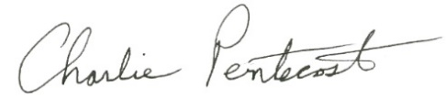Sincerely,

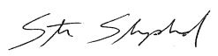

Steve Shepherd, Charlie Pentecost,   
Athletic Director & Sports Information Director  
Head Men’s Basketball Coach